**Cap Stone Project**

**Face Recognition & Detection**

|  |  |
| --- | --- |
| **Name** | Lakshmi Thirunavukkarasu |
| **Course** | AI and ML (Batch 5) |
| **Problem Statement** | Perform Face Recognition & Detection for lfw dataset |

**Software requirements prerequisites**

Anaconda

Python 3.8

Python Packages

OpenCv

Facenet-pytorch

Matplotlib

**Steps**

1. **Create face Dataset**

Downloaded 500 faces from lfw dataset(Note: only 500 faces used for face detection problem due to computational constraints)

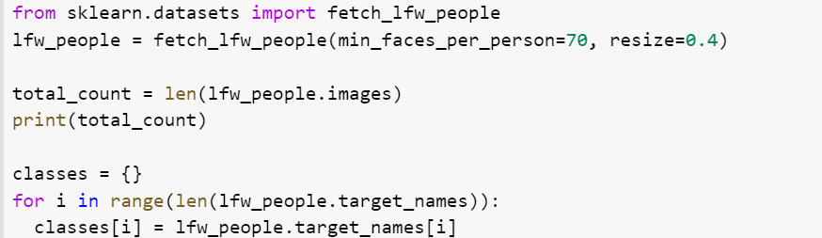

1. **Face Detection using MTCNN**

**Crop and Save the Identity face in the given image.**



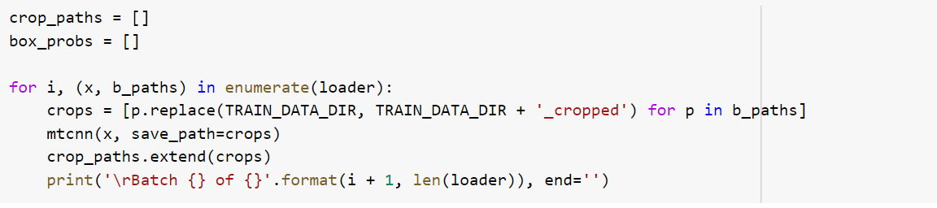

1. **Face Alignment**

Perform transformations on the cropped image.

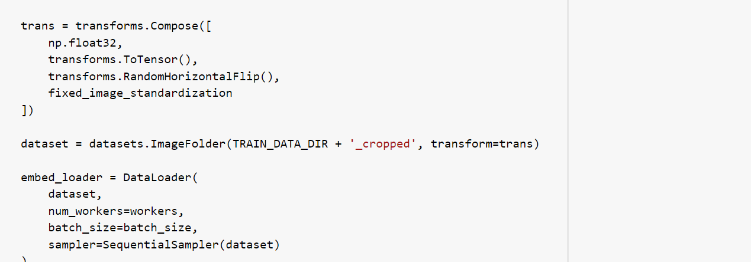

1. **Feature Extraction**

Use Resnet that is trained on vggface dataset to generate 128 embeddings for the given cropped image.

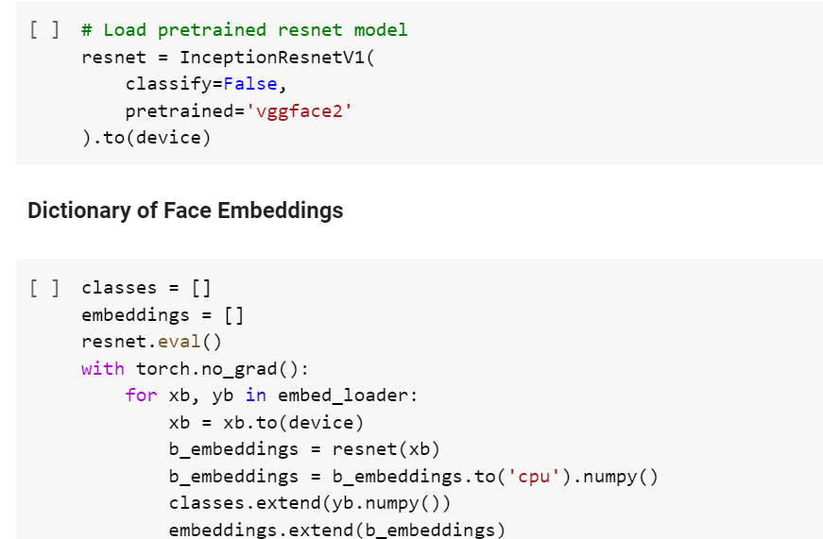

1. Face Verification

Perform the below steps:

1. Create pair of images with similar and dissimilar classes

2. Calculate Cosine similarity for each pair

3. Accept the images belongs to the same class if the distance is less than the given threshold otherwise conclude they belong to different classes.

